Evaluation of the Water Audits of Redwood City Public Works

Introduction

The Redwood City Public Works (RWCPW) has been offering free water audits for residential water customers since 1994 in the hopes of encouraging water conservation. The water audit requires 3-4 hours of labor on the part of the city water auditors, and RWCPW would like to optimize their employee’s time. In 2011, RWCPW sent out 1,000 letters to above-average water consumers offering a free water audit. Only 40 customers requested an audit. Our goals for this project were twofold: (1) to use surveys and interviews to understand the reasons customers chose whether or not to participate in the audit, and (2) to analyze existing data on water use to determine the efficacy of the water audit program.

Literature review

Our literature review included peer-reviewed and grey literature about residential water audits.

A 1993 study of Contra Costa County’s residential water audit program found savings of 30 gallons per day per household post-audit (Bruvold and Mitchell 1993). However, this number may be unreasonably high for Redwood City’s program today because of technical advances and widespread implementation of water-saving technology in the past 15-20 years. A 2007 study in Ipswitch, Massachusetts, for instance, found a median reduction of 11.5 gallons per day per household post audit (“Ipswitch River”). The City of San Diego estimates a 10-18 percent savings in annual water consumption as a result of their audit program (City of San Diego 2002). Similarly, Maddaus Water Management, a local consulting agency, uses 10 percent savings as a conservative estimate in their work (Maddaus 2012).

Several of the articles we read brought up concerns that are very relevant to RWCPW today. For instance, one important aspect of audit evaluation is to ensure that program expenses do not outweigh benefits (Whitcomb 1991). A report published by the California Urban Water Agencies brought up the difficulty of attributing water savings to the audit process. As a result, few agencies in California have completed evaluations or studies of water savings from audit programs (Fiske & Weiner 1994). Although it may be useful to evaluate audit programs, there are clearly many barriers to doing so.

Other sources emphasized the outdoor/landscape audit as a main area for savings (Soulas 2009, Hurd 2006, DeOreo 2011). However, uncertainty regarding the persistence of behavioral changes, especially in irrigation, is one reason to evaluate audit programs (Fiske and Weiner 1994). This concern was echoed in our interviews with Redwood City’s Water Conservation Technicians. Two sources used follow-up visits or phone calls to mitigate this concern (Soulas 2009, Bruvold & Mitchell 1993). Follow-up calls, especially for irrigation, might be one way for RWCPW to increase the persistence of behavioral change.

After completing our literature review, we decided to conduct interviews with other water agencies who have water audit programs. These interviews serve as a supplement to our literature review and a source for context and comparison (see Phone Interviews, Santa Rosa Utilities).

For works cited, see Appendix A.

Surveys

Solicitation and response rate

With our two surveys, we aimed to reach the 40 audit participants and the 960 non-participants who also received invitation letters. We received 8/40 participant email addresses and 111/960 non-participant email addresses. To increase the number of participant email addresses, we tried to access the audit forms, since the email address is an input field on this form. However, since the audit forms were not digitized into a searchable form, we were not able to do so. This ties into our recommendation 1 (d) for the digitization of audit forms. Digitization would allow RWCPW to access email addresses and other information recorded during the audit easily and quickly.

After sending the survey by email, we discovered that 2/8 participant e-mail addresses and 11/111 non-participant e-mail addresses were undeliverable. In order to reach more potential respondents, we decided to mail a postcard which included an invitation and a link to the survey. We sent postcards to all 40 participants and to 110 non-participants. The 110 non-participants consisted of a random sample of non-participants who had not been contacted by e-mail.

After both the e-mail and postcard solicitation, 3/40 participants and 17/221 non-participants contacted completed the full survey. For each of the surveys, one additional person started the survey but did not finish.

Participants

All three participants who completed the survey said that the outdoor portion was the most helpful part of the water audit. In particular, checking for outdoor leaks, recommending a watering schedule, and providing irrigation advice was helpful. One participant reported that he/she did not implement any of the recommendations provided by the water conservation technician during the water audit. The other two both implemented an improved irrigation schedule, and one of them also fixed an outdoor leak that was detected during the water audit.

All survey respondents said that the length of the survey was just right. None of the three respondents knew about the online water use portal, hence our recommendation 2 to use the water audit as an opportunity conduct outreach on the portal. One participant provided additional comments at the end of the survey and suggested that RWCPW send out email reminders about altering their watering schedule when the seasons change.

For full results from the participant survey see Appendix E.

Non-participants
Of the 17 non-participants who responded, 12 said they never received the solicitation letter or they received it, but did not read it. Of these, all but one were unaware of the audit program. One was a landlord, and the tenant was not interested in the program. Another moved into a house which had been vacant, leading to an understandable increase in water use, so the water audit did not seem necessary.

Only 5 respondents actively chose not to participate in the audit after receiving and reading the letter. Among these five, one person responded that they did participate in the program, indicating some inaccuracy in the records on participation. Another responded that refilling a pool during the summer accounted for the increase in water use, so the audit seemed unnecessary. This example indicates the importance of updated budget numbers as mentioned in recommendation 1 (a). Updated budget numbers would improve the accuracy of targeting high users.

Of all 17 participants, only 1 was aware of the online portal. Even this person, however, had not used it. When asked if they would use an online version of the audit, 50 percent believed they would participate in an online version.

For full results from the non-participant survey see Appendix F.

Phone interviews

In addition to the online survey, we conducted phone interviews with three groups of people: (1) participants of the water audit, (2) non-participants of the water audit, and (3) other local water agencies that have water audit programs similar to that of RWCPW. Courtney Rubin provided us with a list of three water agencies to contact: Santa Rosa Utilities, Santa Clara Valley Water District, and East Bay Municipal Utility District. Only Santa Rosa Utilities responded to our calls.
Santa Rosa Utilities
We spoke to Randy Barron, a Water Resources Technician at the Santa Rosa Utilities department about their free residential Water Conservation Check-Up. Santa Rosa’s water audit program has been operating since the 1970s, and has experienced a lot of growth especially since 1995. Barron explained that the Water Conservation Check-Up is a high priority program for the Santa Rosa Utilities department. The department conducts a higher volume of water audits than RWCPW. Currently, they have two teams (four full time staff members and three interns) conducting 6-12 audits per week. The audits last 30-45 minutes, and include both an indoor and outdoor portion.

Similar to RWCPW’s experience, many of the Santa Rosa residents who request a water audit were motivated by an abnormally high utility bill, often in the summer months. The utilities department also advertises the program through bill inserts, billboard advertisements, and radio and TV commercials. They also staff a booth a few times a month at Santa Rosa’s Wednesday Night Market (a combination farmers market and street fair) to hand out water conservation materials and advertise the Water Conservation Check-Up. Although they have a well-established water audit program, Santa Rosa has not conducted any evaluations of the impact the audits have on water consumption. Barron mentioned that a strategic plan was recently completed which included future evaluations of the efficacy of the water audit program. Based on Barron’s own personal “spot checking” on households that have participated in the water audit program, there seems to be about a 20-30% savings in water, mostly due to improved irrigation or fixed leaks.

Participant Phone Calls
We were able to conduct three phone interviews with Redwood City residents that had participated in the Smart Home Water-Use House Call. The goal of these phone interviews was to collect in-depth qualitative information about their experience with the water audit that we could not receive through the online surveys. Our response rate was three interviews out of 12 phone calls.

Participant #1
The first participant we spoke to was a single resident living by herself in Redwood City. She was present during the water audit, and said that the technician only looked at the outdoor portion of her water use. The audit lasted about 15 minutes, and she said that it was not very helpful for her. She explained that her water use is high because she has a lawn and a pool, and she said that the water technician did not provide her with any suggestions on how to conserve water.

Participant #2
The second participant requested the Smart Home Water-Use House Call because of a spike in his water bill. His household consists of two people, and he was present during the water audit. Interestingly, Participant #2 said he was convinced that the spike in his water bill was a mistake by RWCPW and a “trick” on the part of the utilities department to wring extra money out of his household. He said his water bill went back to normal after the spike. In spite of all this, he said he really liked the water audit and that the technician provided a lot of really helpful information about home water conservation. He thought all the information provided was useful, especially the information from the outdoor portion of the audit. According to Participant #2, the technician told him at the end of the audit that his household was already doing really well in terms of water conservation. Although the technician provided some suggestions, Participant #2’s household didn’t implement any of them. He thought the length of the water audit was fine, and that the technician was very knowledgeable and helpful. When we asked about the online portal, Participant #2 said he had never heard about it or used it before.

Participant #3
The final participant we spoke to had just moved into their house around September of 2011. He said their household consists of three people, and they rent the house from the property owner. The property owner had advised Participant #3 to request a Smart Home Water-Use House Call because the last bill had been so high at the end of the summer. Participant #3 thought that the information provided was all helpful and pertinent, especially the irrigation suggestions in the outdoor portion. He said that his household has always been conservative with water usage such as taking short showers and using low-flow shower heads. He thought the audit was very thorough in addressing all his water conservation needs, and he took several of the outdoor irrigation suggestions. Participant #3 also did not know about the online portal and had never used it before.

The phone interviews with these participants lasted about 5 minutes each. These conversations reinforce what we learned from the online survey: that residents find the outdoor portion of the water audit most helpful, and that there is very little awareness of the online water portal.

Non-participant Phone Calls

Similar to the phone calls to participants, the motivation for interviewing non-participants on the phone was to collect opinions and information about the water audits that might not have been easily conveyed through the online survey. Getting a hold of non-participants was considerably more difficult and time consuming than the process of talking to participants. Due to time constraints we were able to interview two non-participants after making 28 phone calls.

Neither of the non-participants believed they ever received the initial solicitation letter from Redwood City Public Works. Both of them already had several water-saving techniques implemented in their homes, including low flush toilets and low flow shower heads. One non-participant stated that his water usage should be low because he has neither a lawn nor a pool. Opinion was split on whether or not an online version of the House Call would be helpful – one non-participant said they would use it, the other said they would not. Finally, neither of them was aware of the online portal.

Data Analysis of 2006-2011 Water Consumption

Excel files were provided by RWCPW containing a variety of information. The focus of the data analysis was to evaluate if changes in water consumption occurred after households completed the water audit. In addition, consumption data from the toilet and washing machine rebate program was evaluated.

General Data Treatment & Assumptions

In order to compile information from numerous Excel files the residential Site ID was utilized. To better track individual household water consumption, data analysis excluded multi-family homes and rentals. A residence was identified as a rental if the service and mailing address did not match. The metric used to evaluate consumption was the ratio of actual usage to budget calculated by RWCPW. Over-consumption was defined as a usage: budget ratio greater than 1. For homes that participated in the audit program, the budget values were assumed to be up-to-date.

Random samples of single family, non-rental residences that did not participate in the audit were chosen as control groups (sample size equal to audit participant sample size). Prior to choosing the random samples for each year, households with default or incomplete budget values were excluded as well as households already used as a control group in the prior year. Based on recommendations from RWCPW, for 2006-2011 a budget value less than or equal to 65 was excluded.

For details of the statistical analyses performed please see Appendix B.

Evaluation of 2007-2010 Water Audits

Water audit years 2007-2010 were chosen for analysis based on the availability of the data. The data was constrained to audit years in which consumption data for the year prior to the audit and the year after the audit was available. This constraint allows for evaluation of the change in water consumption each year. While water usage values were available for 2006 the budget values were not available. For the purpose of this data analysis budget values from 2008 were also utilized for 2006.

While the number of audits performed by RWCPW has decreased with time the relative percentage of households requesting an audit that were over budget did not vary significantly (Figure 1). It is important to note that starting in 2009 Acterra, a non-profit organization, performed Green@ Home energy and water audits for RWCPW. It appears that the involvement of Acterra in home audits greatly reduced the number of audits performed by RWCPW.

Boxplots were utilized to show variability in consumption by year as well as by audit participants and non-participants (Figures 2-5). There were numerous outliers. It is important to note that many of these outliers may be due to incorrect budget values for a given household rather excessive usage. Appendix B explains how to interpret information displayed in a boxplot.

In addition to visually representing the data, nonparametric statistical tests were employed. First a comparison of consumption of audit and non-audit participants was completed (represented by blue boxes in Figures 2-5). In many cases there was not a significant difference between the consumption of the audit and non-audit participants. Next a comparison of consumption pre and post-audit was completed. For the 2007 and 2010 there was no significant difference in consumption pre and post audit. For 2008 and 2009 audits there was a significant difference in consumption. In particular there was a significant decrease in consumption the year after the audit was completed.

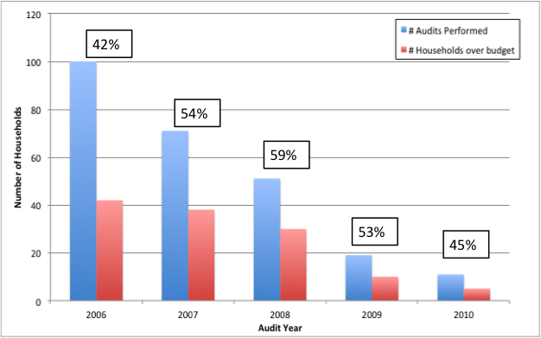
Figure 1. Number of audits performed by RWCPW each year and the number of households over budget prior to requesting a water audit. The percentage above the bars represents the percentage of homes requesting an audit that were over budget that year.

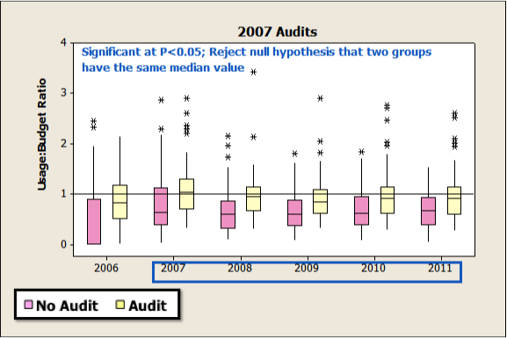
Figure 2. Boxplot based on households completing an audit in 2007 (yellow boxes). The pink boxes represent the non-audit household (control group). The blue box around the years 2007-2011 indicates that in those years significant difference in consumption exists between the audit and non-audit groups.

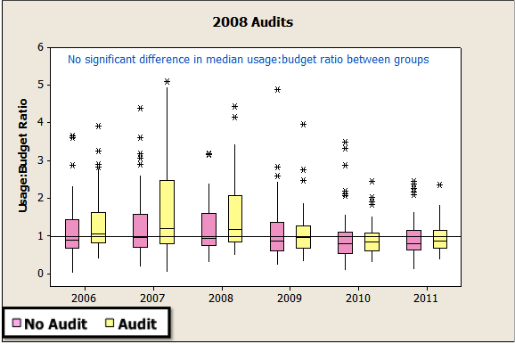
Figure 3. Boxplot based on households completing an audit in 2008 (yellow boxes). The pink boxes recommend the non-audit household (control group). There was no significant difference in consumption between the audit and non-audit groups.

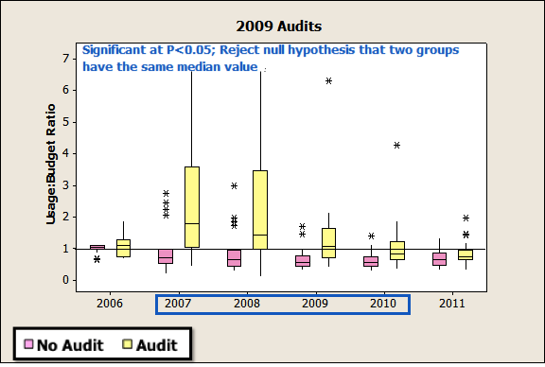
Figure 4. Boxplot based on households completing an audit in 2009 (yellow boxes). The pink boxes represent the non-audit household (control group). The blue box around the years 2007-2010 indicates that in those years significant difference in consumption exists between the audit and non-audit groups.

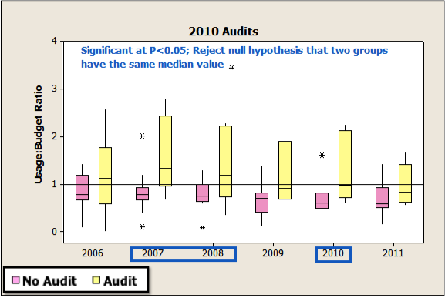
Figure 5. Boxplot based on households completing an audit in 2010 (yellow boxes). The pink boxes represent the non-audit household (control group). The blue boxes around the years 2007, 2008, & 2010 indicate that in those years significant difference in consumption exists between the audit and non-audit groups.
Additional statistical tests were applied to the available data to try to understand factors other than participation in the water audit that may impact water consumption. Water rates paid based on Tier level were matched to each household. There was a significant but weak positive correlation between water consumption and rates paid (Table 1). The users that were over budget by the largest amount also paid the highest water rate.

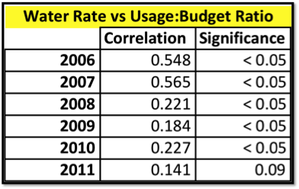
Figure 6. Correlations between water rate paid by household and the usage:budget ratio. For the statistical test utilized correlation values can range between -1 to 1 with -1 being a perfect negative correlation and 1 being a perfect positive correlation. A P-value (significance) of less that 0.05 indicates a significant relationship.

In addition, annual precipitation and the consumer price index (CPI) were examined as other variables possibly impacting water consumption. Within the audit participant group there was no significant relationship between consumption and CPI or precipitation. For the non-audit group there was a significant negative correlation. As precipitation and CPI increased, consumption decreased.

Evaluation of Residential Household Rebate Program

Although the residential household rebate program is not directly linked to the water audit program, a preliminary analysis was conducted to analyze if consumption decreased as a result of participation in the program. There were many more households participating in the rebate program versus those participating in the water audit program. There is a significant positive relationship between program participants and reduction in water consumption (Figure 6).

Figure 7. Number of rebates issued by year. The values listed represented number of households participating rather than the number of rebates issued since some households had multiple rebates in a given year.

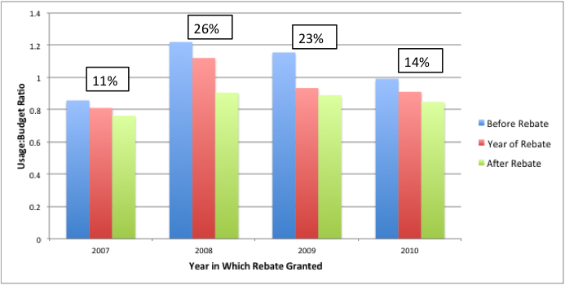
Figure 8 Impact of rebates on consumption by households participating in the rebate program. The percentage above the bars represents the percent reduction in consumption.

Concluding remarks based on data analysis

Our analysis of the water consumption from 2006-2011 showed that changes in water consumption could not be solely attributed to water audits. Participation in the water audit program did not always correlate directly to a reduction in water consumption. Other variables that potentially played a role in water consumption behavior were precipitation, economic conditions, and water pricing structure. A more in-depth analysis using time series, multivariate regression, and spatial analysis may show that other factors impact water consumption behavior (e.g. location of household, income) (Recommendation 1c). Additionally, allocated budget values for residents may not properly reflect water usage needs, resulting in erroneous projections regarding water consumption. Updating the water budget values may allow for a better analysis of the consumption patterns (Recommendation 1a). Since data analysis focused on audits performed from 2007-2010, analysis of water consumption from participants in 2011 audits may show different patterns. The difference in patterns of consumption may be a result of the solicitation program in 2011 targeting high users. This analysis can be conducted after 2012 water consumption data becomes available (recommendation 1b).

While the rebate program is not directly linked to the water audit, a rudimentary analysis of the data shows a significant reduction in water consumption after households participated in toilet or washing machine rebates. A more in-depth analysis using control groups is necessary to properly evaluate water savings as a result of participation in the rebate program.

