John Gill Elementary Safe Routes Program
To: | Safe Routes Coordinator
From: | Stanford Safe Routes Team
Date: | June 2011
Re: | Program Recommendations

Dear Safe Routes Coordinator,

While there is currently no established Safe Routes Program at John Gill, there is great potential for one to be started. After spending the last ten weeks working with John Gill Elementary and Redwood City community partners, we have compiled our recommendations based on research and participation with the school staff and parents. This memo includes the steps we took throughout the project, our results, and final recommendations to start up the program next year.

The following is a brief summary of the steps we took and what we learned throughout the process of working with John Gill that will be useful for future work with John Gill and other schools.

- We attended a PTA meeting and met with the Principal at the beginning and received valuable comments, concerns, and contact information that
- We asked teachers to do a tally in their classrooms asking students how they arrived to school that morning. With the high response rate (82%), we used the Teacher Tally as a way to cross-check how representative our parent survey was by comparing the resulting modal splits.
- We distributed a parent survey to all the parents in English and Spanish with help from the principal. From this data, we learned how students currently get to school: approximately 20% walk, 70% drive, and fewer than 8% carpool. The survey gave great feedback for initiating the program with nearly 70% of parents reporting interest in participating in a Carpool or Walkpool program.
- We made a presentation in Spanish at a parent potluck and fundraiser put on by a group of Spanish-speaking parents which allowed us to reach a more representative sample of parents. This document includes a list of interested parents collected from the PTA meeting and parent potluck. The two parents who showed the most interest in following up with the program are Jason Culverhouse and Craig Guinasso.
- We drew on case studies from both outside and within Redwood City in making our recommendations. Our main takeaways were the need for a program champion and coalition, the importance of holding a kick-off event, and the necessity of implementing traffic infrastructure improvements. These case studies can be found as background material on the website, which will be explained below.
- We created GIS maps illustrating student density and their distance from the school. These led us to our recommendations for potential locations to start Carpool and Walkpool programs, and are attached to this memo.

The following is a brief summary of our main recommendations.

- We recommend several infrastructure improvements that we developed with help from parent Craig Guinasso, a former traffic officer. Our suggestions are applicable to the area immediately surrounding the school, and include:
- Moving the traffic light from the intersection of Hawes Street and Jefferson Avenue to Myrtle Street and Jefferson Avenue
- Replacing the planter adjacent to the school along Myrtle Street with a loading/unloading zone
- Improving the No U-turn signage on Myrtle Street

- We propose starting a Carpool/Walkpool Program by organizing parents into small groups that can bring several students to school by car or walking. This Carpool and Walkpools will increase the safety of drop-off by reducing number of cars and spreading out drop-off times. They also may have the additional health, environmental, and community-building benefits.

- The Walkpool program should be integrated with Morning Momentum, a walking program led by parent Thea Henry-Hamilton. Morning Momentum should be continued and supported with expanded resources, as it helps spread drop-off times and encourages healthy behavior.

- These ideas will be most effectively implemented if combined into a Kick-Off Event, hopefully coinciding with a large Walk to School Day during October, which is International Walk to School Month. This would be facilitated by a committee or coalition of parents, interested teachers, and Redwood City contacts.

We have created a password-protected website, saferoutesrwc.posterous.com, which compiles all of our resources, data, and recommendations. The password is “saferoutes” and will be useful as there is contact information and data that the school may not want to release. To edit the website, you can use the email address we created for the program, JGsaferoutes@gmail.com. The password for the email is also “saferoutes”.

We have thoroughly enjoyed working on this project and hope that it has produced useful results. Please contact the School Liaison, Anna Ponting, at aponting@stanford.edu or (619) 757-9754 if you have any further questions.

Sincerely,

Stanford Safe Routes Team
Nicole Greenspan
Hannah Kohrman
Anna Ponting
Ellie Titus
Sam Wright

Implementing Safe Routes to School: A How-To Guide
Nicole Greenspan, Hannah Kohrman,
Anna Ponting, Ellie Titus, Sam Wright
Stanford University
Spring 2011
Overview of Steps John Gill Example Timeline

1. Observe school drop-off and pick-up.
- Go to the school in the morning and observe drop-off behavior.
- How many cars came throughout the morning? What time did the peak density of cars occur? Was there any observable, unsafe driving behavior?

2. Meet with the school principal.
- Set up an initial meeting with the principal to get him or her on board.
- Identify his or her main source of interest: safety, environmental, health or other.
- Identify challenges, concerns and resources, including people and funding.
- Ask the principal to identify community members he or she thinks would be interested.

3. Attend a PTA or other community meeting.
- Propose a safe-routes project and gauge interest.
- The most important thing is to listen to what they want. Parents are a main stakeholder and no program can work without them.
- Identify challenges, concerns and resources, including people and funding.
- Look to identify a “program champion” from within the school.

4. Conduct a student survey with teachers' help.
- Have teachers record how their students get to school.

5. Survey parents.
- How do their children get to school? Collect this data to see potential for growth of a Safe Routes program. Additionally, it is best to use already popular pathways to school.

April 11, 2011

April 11, 2011

April 12, 2011

April 29, 2011

April 29 – May 1, 2011

- Are they interested in a carpool or “walkpool” programs?
- Try to maximize survey response rate. E.g., at John Gill the students took the surveys home in a packet that already goes out each Thursday, and the principal made an incentive for students to bring back the survey by promising an ice-cream party to the three classes with highest return rates.

6. Evaluate survey responses.
- How do most students get to school?
- How many parents are interested in a Safe Routes, carpool or “walkpool” program?

7. Map where students live.
- Obtain anonymous student addresses, if possible, and plot them on a map.
- Focus on homes that are close enough to the school to walk.
- If possible, create a “heat map” to show density and clusters of student homes in the neighborhoods around the school. This is a useful tool for identifying potential meeting points for carpooling or “walkpooling.”

8. Hold an initial coalition meeting.
- Identify leaders and coalition members and bring them together.
- Main leaders of the program may include principal, teachers, parents or invested community members (e.g., representatives from Redwood City 2020).
- Decide when and how to jumpstart the program.

9. Hold a large-scale Safe Routes kick-off event.
- Include a police presentation on driver education and safety.
- Get students and parents excited!

May 2 – May 4, 2011

May 4 – May 11, 2011

We attended a Parent Potluck instead to reach out to the Spanish-speaking parents and build a more representative coalition.
This will take place at the beginning of next school year.

Next Steps and Recommendations
1. Hold a Coalition Meeting
- This should occur at the very beginning of next school year
- Contact parents who have already shown interest (included in this packet)
- Solicit involvement from parents new to John Gill
- Integrate support for Morning Momentum and broaden the program so that it is not reliant on a single parent
  - Morning Momentum is an activity where students walk laps around the basketball court and record their distance, and the school tries to reach a goal by combining their distances.
  - Currently, the program is entirely dependent on parent Thea Henry-Hamilton, and needs more parent volunteers (or possibly older student participation to build leadership skills).
  - This program encourages students to arrive to school early to walk, and helps spread out the drop-off times so that there is not a dangerous rush right before school begins.

2. Hold a Kick-off Event
- This will be most effective if held in conjunction with International Walk to School Day in October
- Join with Redwood City 2020, who can provide funding, and other community partners
- Look into having a police presentation about driving and walking safety
- Provide incentives and prizes to students who participate
- Use this as a way to launch a Carpool and Walkpool program
  - Offer sign-up sheets and collect contact information for clusters of nearby parents
  - Encourage the program to start at a small scale: the carpools and walkpools can be held only on Fridays, for example

3. Implement Traffic-Calming Measures
- A more detailed list of infrastructure improvements follows
- Work with parents Craig Guinasso and Jason Culverhouse specifically, who seemed most interested in taking on the role of Program Champions

Traffic-Calming Measures

To brainstorm traffic-calming measures, we sought input from stakeholders and conducted our own research. Craig Guinasso, whose child attends John Gill Elementary, came forward at the April 12 PTA meeting to offer his expertise. Craig is a former police offer for the California State University system. In order to make the brainstorm as productive as possible, we agreed that he should make suggestions as if cost were no object. Below is our synthesis of his suggestions.
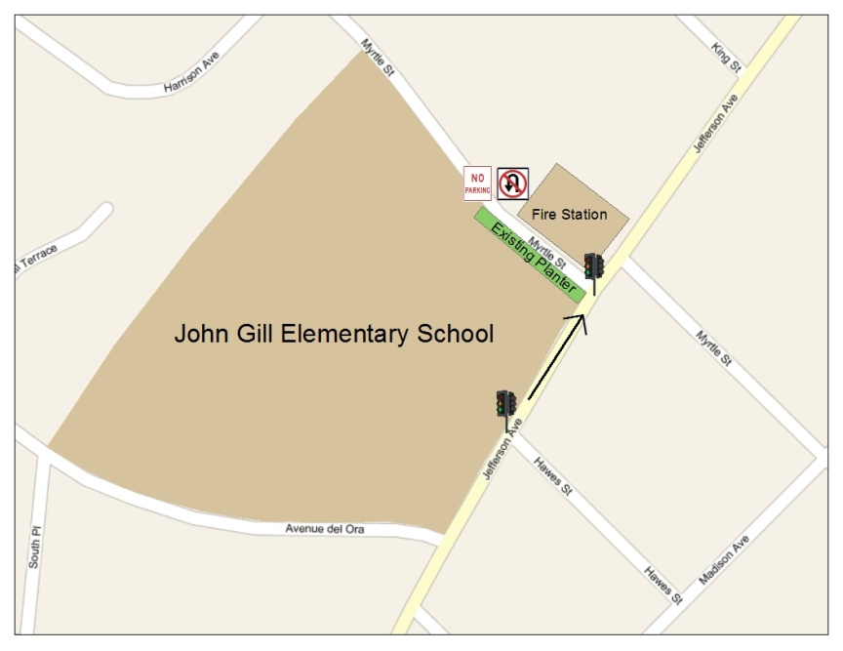

Point A: John Gill Elementary School, with drop-off zones on Avenue del Ora and Myrtle Street
Point B: Jefferson Avenue station of the Redwood City Fire Department
Note: There is a stoplight on Jefferson Avenue at Hawes Street

- Move the stoplight to Jefferson and Myrtle. The fire department would likely support this, especially if it could trigger the light to turn red when a fire truck leaves the station. The light would further reinforce the right-turn only onto Jefferson from Myrtle (see next suggestion).
- Southbound Myrtle onto westbound Jefferson should be right-turn only. Northbound Myrtle, on the other side of Jefferson, is already set up this way. Reflective dots on the road should highlight this turn.
- On the westbound side of Myrtle Street is a planter area, between the sidewalk and the curb. This planter should be replaced by a loading zone similar to the one on Avenue del Ora. In addition to improving school drop-off, this would allow better access to fire trucks leaving and returning.
- No-parking and stop signs should be placed on the east side of Myrtle, to apply on school days between 8 and 9 a.m. and between 2 and 4 p.m. Residents could receive permits to remain parked there during those pick-up and drop-off times.
- “No U-turn” signage on Myrtle should be improved. A simulated barrier could be painted there (see 21651(a) VC).
- Consider conducting a traffic survey and lowering the speed limit on Jefferson. (At least one traffic survey is believed to have been done prior to the beginning of radar use by police.)
GIS Maps

Based on analysis of the map of student address density, we recommend these areas as preliminary Carpool or Walkpool Hubs. These are the areas with that are dense with student addresses, and convenient locations for Carpools and Walkpools.

- Madison Avenue and Hudson Street
- Clinton Street and Vera Avenue
- Lincoln Avenue and Adams Street
- Stanley Street and Westgate Street
- Clinton Street and Harrison Avenue

Map 1: Student Address Density
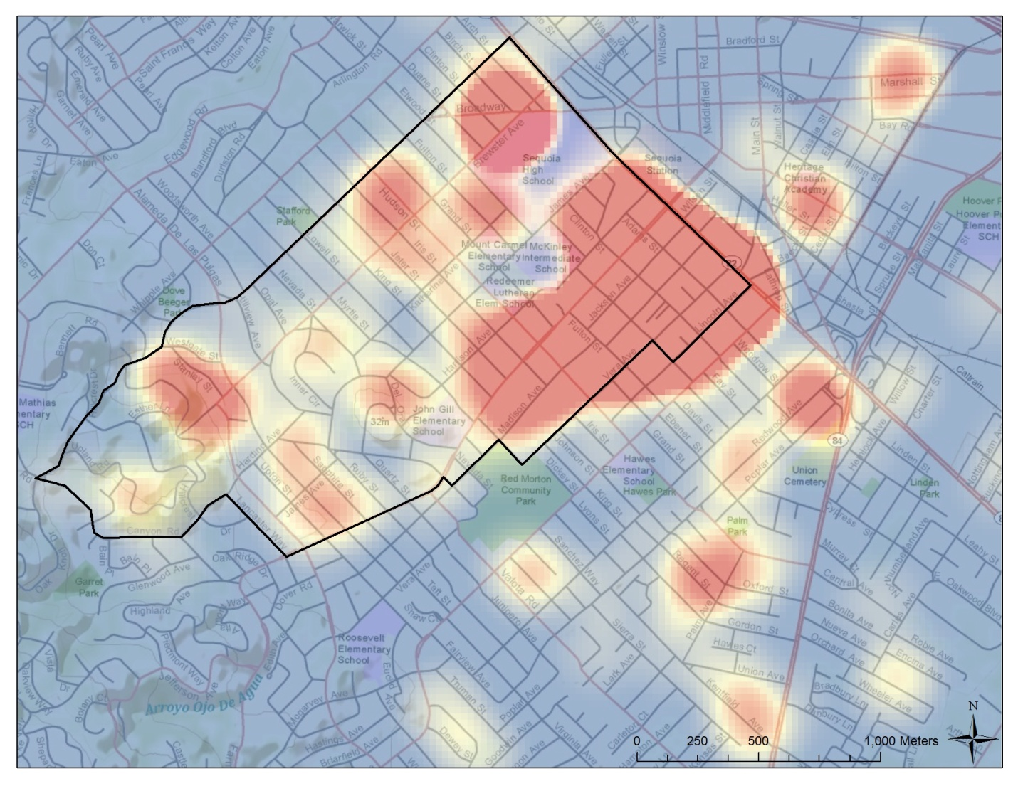
Color Scale: The color scale of blue to red indicates how many student neighbors are located within 200m of an address. Blue indicates zero student neighbors; red indicates five or more student neighbors.

Teacher Tally Results

Date of Survey: April 29, 2011

Mode of Transportation | Number | Percentage
Family Vehicle | 247 | 67.5%
Walk | 86 | 23.5%
Carpool | 18 | 4.9%
Bike | 8 | 2.2%
School Bus | 5 | 1.4%
Response Rate | 366 of 447 enrolled | 82%

Parent Survey Results

Date of Survey: Late April, 2011

Mode of Transportation | Number | Percentage*
Family Vehicle | 79 | 71.1%
Walk | 24 | 21.6%
Bike | 4 | 2.2%
Scooter | 3 | 1.4%
Response Rate | 94 of 447 enrolled | 21%
*Adds up to more than 100% because some parents reported multiple modes of transportation
Do you participate in a carpool?
- 7.1% of parents responded yes

Would you be interested in participating in a Carpool and Walkpool Program?
- 69% of parents responded yes

Parents’ main concerns:
- “Relying on others to pick up kids on time”
- "Early morning rush- will need to get the kids ready earlier for walk; streets are busier in the morning, and drivers are in hurry- danger!”
- "Mostly scheduling- my work schedule is very erratic."
- "In case of accident I don't want to be exposed or responsible for the safety of other kids"
- "Traffic on Myrtle & Avenue del Oro- dangerous habits of parents"
- "Making sure my daughter is dropped off and picked up on time"
- "Knowing person walking with group is trustworthy"

Language Statistics:
- 73% responded in English (65 surveys)
- 27% responded in Spanish (24 surveys)

