To: Shauna Mora and the Peninsula Conflict Resolution Center (PCRC)
From: North Fair Oaks Youth Engagement Initiative, “Sustainable Cities,” Stanford University
Sarah McCurdy, Mona Thompson, Gary Chan, Marcus Jamison
Subject: Youth Engagement in North Fair Oaks: Youth Workshop Plan

Recommendations:
We are recommending that PCRC use the results from our pilot youth engagement workshop to implement a workshop with 2-3 other youth groups to get more feedback on the North Fair Oaks Community Plan. A key component to our design was that we looked at what do we want to know and what do we want the students to gain, and then made engaging and appropriate activities surrounding those two questions.

Outline of Memo
1. Why a Workshop
2. Best Practices
3. Overview of Lesson Plan
4. Results from Pilot
5. Recommendations for Implementation

Appendices:
- Specific NFO Youth Engagement Lesson Plan (pg. 4)
- Feedback from Workshops (pg. 9)
- Slides from Workshop (pg. 11)
- Takeaways (pg. 15)
- Baltimore Case-Study Review (pg. 18)

1. Why a workshop
A workshop allows planners to have in-person interaction with young people in an informal environment to gather immediate and in-depth input about a planning document and/or process. In addition, participants learn about and feel engaged in the planning process. At the same time, workshops can aid in plan implementation by generating community acceptance.

2. Best Practices
This list of best practices for youth engagement workshops is compiled from information from Youth Engaged in Leadership and Learning (YELL), The Baltimore City Department of Planning, REACH (A Program of Sierra Health Foundation), and a discussion with Fahad Qurashi and Emily Lehr-Anning from Youth Leadership Institute (YLI).

Timing
- 1.5 - 2 hours/session

Space Set-Up
- Make the agenda visible to everyone
- Be inclusive: set up the seating in a circle
- Move around, stay high energy, keep the session upbeat and interactive

General Notes on Interactions
- Respect
  - If possible, get to know the group before the workshop by researching their accomplishments, observing a workshop, and getting to know a couple of the members at least by name.
  - Let youth know that they are the center of the process: share your authority, avoid lecturing, ask questions.
- Clarity
  - Be as clear as possible with explanations of concepts and check in frequently with youth to make sure everyone is on the same page.
  - Give youth clear roles, especially within smaller groups (e.g. timekeeper, note-taker, etc.)
  - Work to make the information personal to the students in the room.
- Energy
  - Stay high-energy, fun, and upbeat.
  - Incorporate different types of activities - small, break-out groups are good especially for quieter students, and put in a couple higher energy activities to keep things moving.

Follow-Up
- Let the youth know during the workshop how their contributions will be used and what else they can do to be involved.
- After the workshop, follow up with the group about what is happening with their contributions and the influence they are having in the planning process.

3. Overview of Lesson Plan

Objective:
- To inform youth of the planning process
- Have youth understand the current conditions of NFO and why we need to have a plan
- Obtain ideas and proposals from the youth pertaining to Parks and Recreation, Transportation, and Access to Healthy Food

Strategies:
- Quiz Game Competition: high-energy opener to get youth excited about the workshop and orient them to the topic.
- Small Group Discussion: obtain high-quality feedback on different topics
- Closing/Reflection: provide opportunities for continuing involvement and evaluation of program

4. Results from Pilot

Complete results from the pilot can be seen in Appendix II: Feedback from Workshop on pg. 9.

Parks and Rec:
- A couple more Big Parks a few more smaller parks/meeting locations
- Greater Maintenance
- Eco Friendly (recycling bins, use less water more trees)

Transportation:
- Walking and busing identified as primary modes for youth
- General satisfaction with navigability of NFO
- Issues primarily related to bus service and accessibility issues related to train tracks

Access to Healthy Food:
- Want more inexpensive organic and healthy foods
- Fewer stores with liquor and tobacco and more strict regulations/enforcement on selling to minors
- Clean up outsides of restaurants and stores

5. Recommendations for Implementation
- Run the workshop (see Appendix I on p. 4 for complete lesson plan) 2-3 more times with different groups for more comprehensive feedback.
- Follow up with students who wrote down their contact information on how their feedback from the workshop is being used and give opportunities for future engagement.

Appendix I:
Specific NFO Youth Engagement Lesson Plan
The Intro:
- Welcome (10 min)
  - Introduce ourselves (name, grade). We’ve been talking with a lot of people about this workshop including Shauna who did a workshop with Migrant Youth a while ago and Fahand and Emily from YLI who said you all rock. So we are so excited to be here.
  - Have everyone go around in a circle and say their name and HS
  - Description of why we’re here
    - Class at Stanford
    - Working with different people in the planning process to get youth – you all - involved in the update of the North Fair Oaks Community Plan, which we’ll talk more about in a second.
  - The purpose of this workshop is to get your opinions and feedback on what it’s like to live in North Fair Oaks and what you would change or want the people making the Community Plan to think about. We are going to give all of your suggestions to the planning committee and we’re going to present them on Thursday night at a Steering Committee meeting, who are the people working on the plan. You’re also going to have the chance to tell us what you thought of the workshop at the end so we can improve it for when it gets done again.
  - Does anybody have any questions about this workshop or anything I just talked about?
  - Now I’m going to turn it over to Marcus who’s going to go through what we’re going to do in the next hour or so.

- Agenda
  - Intro-Small groups (Park and Rec, Transit and Healthy Foods)-Closing/Wrap Up

- The Competition! (20 min)
  - Split the class into 2 groups. (Optimally, they would either sit on the floor or chairs facing each other with a large gap in the floor. When a question has been read aloud, each group will consult and then a different person each time will run up to the board.
  - When the person picks up the marker they have to either say or point to the answer immediately. If not they lose their turn. If they get it right then their team gets 1 point! If they get it wrong, nothing happens and the other team has a chance to answer. The winners get a prize (in this case, we gave out Stanford pencils).
  - Regional Context- have students come up and point to where we are
    - Where in the world are we?
      - We live in one of the most advanced and developed nations in the world.
    - Where in the US are we?
      - We live in California, where our state government and economy are bigger than most other nations.
    - Where in California are we?
      - We live in the Bay Area, the 8th biggest metropolitan area of our nation, filled with diverse people who come from many different diverse cultures, and have varying wants and needs.
    - There are 9 counties in the Bay Area, which one are we in?
      - Yes, San Mateo County. With a population of over 700,000 there are again many different wants and needs in the county, this becomes more difficult when there are about 18 unincorporated areas spread throughout the county.
    - Where are we in San Mateo County
      - North Fair Oaks
    - Is North Fair Oaks an incorporated city, or an unincorporated area?
      - North Fair Oaks is an unincorporated city, sandwiched between two incorporated cities: Redwood City and Atherton.
      - Unincorporated means that there is not a local government specifically for that area. The government is the county, which in our case looks over 17 other unincorporated areas and 20 incorporated cities and towns going from Half Moon Bay on the Coast to East Palo Alto on the SF Bay to govern.
    - Let’s take a minute to look at this map of North Fair Oaks
      - Show the three sections of NFO separated by the railroad tracks.
      - Show where the schools are, Middlefield Rd. 5th Ave, El Camino
    - Now we are going into why we have a plan. When was the last time NFO had a general plan?
      - 1979! About 32 years ago.
    - What major transportation change might be coming through NFO in the near future?
      - CA High Speed Rail will be coming through and there will be a station either in RWC 1 mile away or Palo Alto 2.5 miles away. It is an environmentally friendly way to travel around California
    - Last Question: (have both teams write their answers down)(1 point for each “good” response. Think of as many reasons (max 5) for why NFO would have a community general plan. Some examples to make sure to cover:
      - The community needs have changed
      - There are hopes to improve the quality of life
      - To encourage economic development
      - And they can come up with more

- The Planning Process
  - Brief slide showing the planning process, where we are and the steps of what we get today that will move forward.
  - Time for questions about the plan

- The Pitches for the different Subgroups
  - Parks & Rec: in MP and RWC there are about 3 acres of parks to every 1000 people, in NFO there are .03 acres of parks to every 1000 people
  - Transportation: NFO has two major railroad tracks going through it that separate this small area into three even smaller sections, but there is not one station, and we are just left with huge barriers that prevent the community from growing.
  - Healthy Food: While 99% of people are a quarter of a mile to a grocery store or food market, all residents are also in walking distance to a liquor store and 85% are ¼ mile from at least 1 fast food restaurant.

- Separate into different subgroups

Breakout Sessions (45 min) (20 min. each with 5 min break):

Parks and Rec:
Key question(s):
What do you like to do in parks?
What do you want to do in parks?
Where do you like to have a new park?

Materials: Markers, paper, post-it notes (preferably green), scissors, blown up map of parks and vacant areas of NFO.

Agenda
- Nametags (2 min to make 5-7 min to present)
  - Everyone writes their name (big) and what they like to do in their local park (smaller)
  - Everyone goes around and presents their name, their school, their grade and what they do in their local park
- Current Conditions (The lecture portion) (3-5 min)
  - Have a chart of “different things to do in parks,” “what people do in parks in NFO now,” and “what would you change?”
  - The Potential of Parks
    - Parks can host a variety of activities both formal and informal, and provide healthy opportunities for healthy lifestyles and wellness
    - NFO has the highest prevalence of unhealthy behaviors in the whole county
    - NFO youth are well below target rates for physical activities
  - Problems with existing Parks
    - There are few parks
    - There is no fundraising money
    - Parks are not maintained
  - Access to current Parks
    - (have about 16% of the group stand up) only 16% of residential parcels are within a quarter mile of parks and open space
- Post-It note Activity (5-7 min)
  - Pass out a green post-it note to each student
  - They use scissors to pick the shape of the park, (like long and skinny, a square, a star whatever)
  - Write what they want to do in a park, on their cut post it note
  - They place their park on the big blown up map
  - Have them present to the group
    - note-taker needed
- Any other comments and concerns can be discussed about Parks and fun areas in NFO (rest of the time)

Transportation
Key question(s):
Where is the greatest need in improvement to youth-accommodating transportation infrastructure?

Materials: large sheet/roll of paper, large post-it, individual post-it notes (3 colors), markers

Agenda:
- Icebreaker activity (2 mins)
  - Questions: What is your name? If you could ride any animal to school, what would it be and why?
- Introduction to transportation issues (5 mins)
  - Sort selves along spectrum based on responses to statements:
    - There are places in NFO that I would want to go to (more often?) if they were easier to get to.
      - Along spectrum, draw a picture of one or two places and write the name of place
    - I find it easy to get around NFO on my own or with friends.
      - Draw picture of main modes of transportation
- Think Pair (Scramble) Share (13 mins)
  - Think: write down (on separate post-its, sorted by color): 1 good thing about transportation in NFO, 2 things that could improve
  - Pair: pair up, decide on one of each that could use improvements, and brainstorm solutions
  - (Scramble): if group <6, repeat pair activity with someone else. Encourage to use other needs improvement
  - Share: each person choose one they worked on to share with the group
- Additional comments/questions

Healthy Foods:
Key question(s):
How do youth understand healthy food, and what are their views on existing access to it?
What changes to existing food networks and infrastructure should result from this?

Materials: Large post-it with “FOOD IN NFO” written in a circle in the middle, smaller post-its, pens

Agenda:
- Get a volunteer time keeper to tell the group when we have 5 minutes left.
- Icebreaker activity (2 mins)
  - Go around the circle name favorite foods/restaurants
- Gather information re: food in community
  - What are some things you like about food in NFO? (write those down in one color) (4 minutes)
  - What are some things you don’t like about food in NFO? (write these down in another color) (4 minutes)
  - Now everybody is going to get two post-it notes and you can write down either two good things that happen because of some of the things we like about food in NFO or two bad things or problems that come out of the things we said we don’t like about food in NFO. Or you can write one of each. And when you’re done writing, put your post-its up next to the topic on the poster that it relates to. (Choose one to do a group example with.) (4 minutes)
- Brainstorm solutions as a group (4 minutes)
  - Ask for a note-taker and give them a pen and new sheet of paper (in the workshop we rotated note-takers).
  - Go through the different problems they discussed (prompt as necessary) and brainstorm possible solutions or ways to fix those problems (in your perfect world, what would change?) Have note taker write down all responses.

Potential topics to raise (in case discussion slows):
-Proportion of healthy to unhealthy foods
-Location and access to healthy foods

Conclusion (10 min):
Note: we only had an hour and a half for our session and did not have time for this part but would recommend it as a part of a two-hour session.

- Bring everyone back in a circle
- Ask for a group note-taker to take notes on a big sheet of paper
- Go through each breakout session and each leader of the session asks what people learned and what interesting ideas came out of each session (about 3 min / section). Have note taker write down all ideas.
- If time, ask for any final questions or comments

Feedback/Evaluations
- Explain video part and pass out evaluation forms and sign-up sheet if people want to be kept updated about the process in the future.
- After evaluations are collected, time for questions about college at the end.

Appendix II: Feedback from Workshop
Results/feedback from the workshop evaluation form given to participants at the end of the workshop.

Participant Demographics (7 participants total):
School: 6 Sequoia students, 1 student at Cañada College
Affiliation: 3 students from Migrant Youth
Gender: 4 female, 3 male

Average rankings of questions on a scale of 1 (Strongly Disagree) to 5 (Strongly Agree), with 3 as Neutral.
- I now feel like I have a good understanding of the planning process for the community plan: 4.57
- I felt like my voice was being heard: 4.86
- The workshop was interesting to me: 4.86

What was your favorite part of the workshop?
GENERAL: Varied responses.
- My favorite part of this workshop was the small group plannings.
- Learning about NFO how it is an unincorporated area.
- Discussing about ways to make the community healthy and how to add new parks.
- Speaking to the different people and voicing my opinion.
- Being able to express changes we want to take place and knowing other people would hear about.
- I actually liked the whole workshop. Everything was really good information and well planned.
- The game of fun facts about north fair oaks.

What is one things that you would want us to improve or do differently when a workshop like this is done again?
GENERAL: People were enthusiastic about the workshop. The two suggestions that came out were to not have it during the summer so we could have higher attendance and to spend some more time in the break-out sessions. Miriam also suggested adding music during the Quiz Bowl competition at the beginning to make it more fun and competitive.
- I think you guys did great, the ice breaker was fun, it was a good way to start out.
- I like that you take into account the opinions of youth, but also think about how can you get youth involved to better NFO.
- Well if we were informed earlier instead of during vacations then there would be more students.
- Well just get more people but small groups work well.
- More time for each workshop (even though this was a trial). It went great :)
- I wouldn't change anything I would just have a little bit more time in each section.
- Nothing really :)

What is one thing that you want to make sure that the people working on the North Fair Oaks Community Plan know to think about when they're making the plan? (This could be one of the things we already talked about in the workshop or it could be something new.)
GENERAL: Again, no huge consensus, but an appreciation for youth outreach and encouragement to get even more.
- I want them to think about who they're targeting the parks or changes to.
- How to better the schools
- More organic fruits, vegetables and foods for cheaper prices.
- Transportation.
- Youth do want to incorporate their ideas you just have to be willing to find them.
- I think everything is said the only thing we should think about when planning a better community is on what people need.
- The trains need to be worked out. The noise. Pollution on north fair oaks.

Interested in being more involved? Fill this sheet out if you want to get a few emails about the other things you can do to help out with the planning process!

We recommend contacting these students with updates about how their input is being used as well as any other opportunities to be involved.

NAME | EMAIL | SCHOOL
Roberto Pablo | roberto_pablo10@hotmail.com | Sequoia High School (SHS)
Seema | blueitseems@gmail.com | SHS
Vivian | vivster94@yahoo.com | SHS
Luis | Ortiz_Luis_E1@yahoo.com | Cañada College
Mariana | Mariana.Arellano25@yahoo.com | SHS

Appendix III: Slides from Workshop



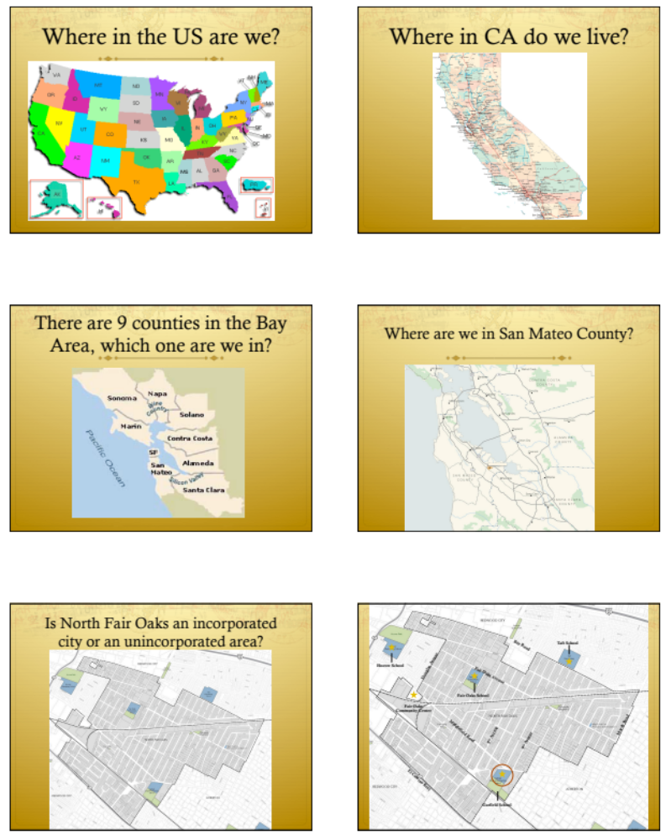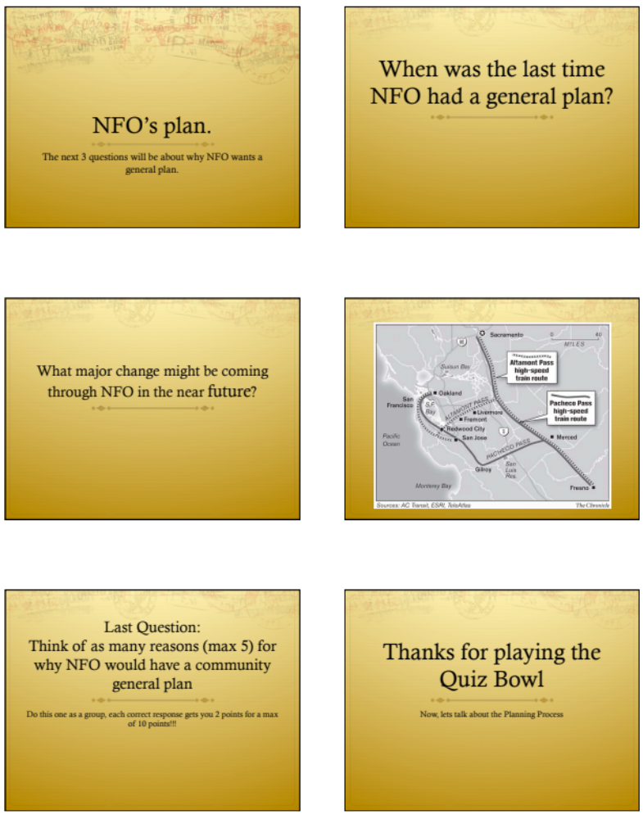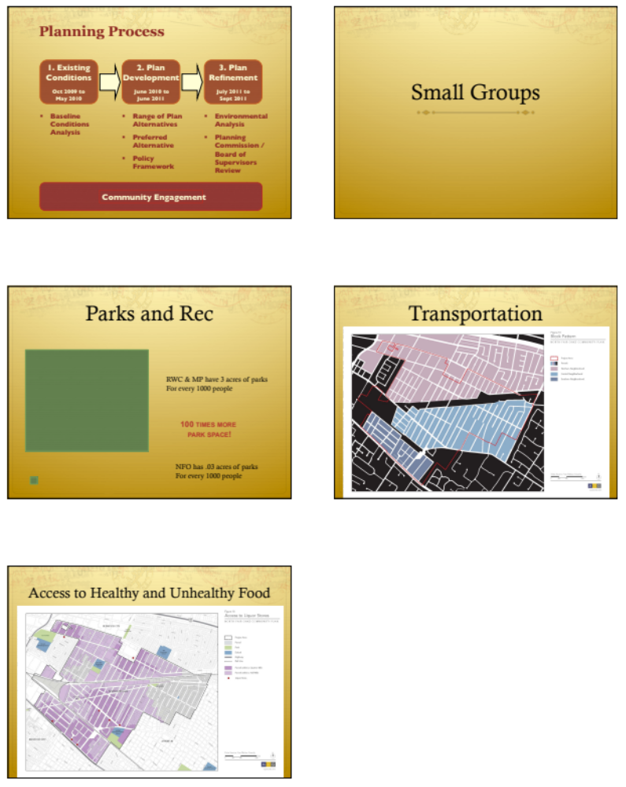

Appendix IV: Takeaways:
Parks and Recreation Small Group:
The general consensus was that NFO needs a couple of more big parks and a lot more, smaller meeting spaces. There is a roundabout/median somewhere with benches and trees and the groups seemed to really like that. Below is a chart of what the youth currently do in parks and what they would change about existing parks, and what they would add into their perfect park. After that I will describe where they think are the best places for new big and small parks.

What people do in Parks, now?  Walking around  Watch people  Walk the dog/play  Play soccer  Play Football  Other people smoke  Listen to music  Slide  Swing  To enjoy the weather  Sit on the grass  Play games  Throw parties  Have a bounce house  Eat ice cream and food! | What would you change? What would be in your perfect park?  Better quality Parks  Big Field  Greater Maintenance  Swimming Pool  Be Eco-friendly- recycling bins, use less water, more trees  Animals allowed (dog park)  Able to play on grass  More no-smoking signage (its a rule but not enforced)  No graffiti  No trash  Bigger (More space)  Big Play ground  Black Tops  Provide Equipment (even though they might get jacked)  Tennis Courts and skate park  Tables/Benches and Grills  Parking Spaces  Less Police (unattractive to be around)  Park Ranges (that give info and help out)

Bigger Park Locations:
Spring and 5th
Spring to Fair Oaks and Barron
Middlefield and Semicircular
El Camino and 5th to Amherst

Smaller Park Locations:
Marlborough and Buckingham
Middlefield and Dumbarton
Loyola
5th and Pacific
6th and Pacific
5th and Northside
(And others in various locations scattered around NFO)

Transportation Small Group:

Key Points:
- Walking and busing identified as primary modes for youth
- General satisfaction with navigability of NFO
- Issues primarily related to bus service and accessibility issues related to train tracks

Students’ primary mode of transportation in NFO was walking and busing. Generally were satisfied with walking, as well as busing as a mode of transportation (though, some problems still existed; see below).

The students’ main issues were concerned with existing bus service. In particular, students repeatedly noted crowded buses during peak hours (morning and after school), and suggested larger buses or a higher frequency of buses as a means of meeting the higher demand during these select hours. Students also pointed out the need for more accurate bus schedules.

The other set of issues raised by students was concerning the lack of train access in North Fair Oaks. Students suggested a train stop, similar to the weekend-only stop in neighboring Atherton. In addition to providing train access to the community, the creation of a train station would also ideally provide another means of crossing the train tracks that currently divide the North Fair Oaks community.

Though these were the main issues, students also pointed out traffic as an issue, though this was a minor issue relative to the aforementioned issues already raised.

Access to Healthy Foods Small Group:

Key Points:
- Liked inexpensive organic and healthy foods – would like to see more of this in NFO
- Want to see fewer stores with liquor and tobacco and more strict regulations and enforcement of not selling to minors or enabling people to buy for minors.
- Restaurants and stores in NFO are dirty/unappealing and would be better if they were cleaned up.

Things you like about food in NFO | Consequences / products of that thing
Sigona's Market (local & organic food) | - Live longer  - Really good organic fruits and vegetables that most stores don't provide
El Grullense

Things you don't like about food in NFO | Consequences / products of that thing
El Grullense
Fights (outside bars) | Police involvement
No good restaurants in NFO | They are dirty from the outside and in. A lot of smoke.
Environment around restaurants: trash and train noises | People not wanting to go in
El Grullense
Tobacco: owners don't know ages and the people at the cash register don't know / don't enforce it
Too many liquor stores: easy access to alcohol – stores sell it and other people buy it for minors | - Too many drunk people  - Teen violence  - Addiction

Possible solutions / recommendations:
- For alcohol/tobacco problems:
  - Close liquor stores / limit liquor licenses (so it is harder to apply for them and regulations are enforced more)
  - More police (more police presence would make it less likely that any fights or selling to minors happened at liquor stores.)
  - Alcoholic programs to help teens and adults (programs like Alcoholics Anonymous)

- For restaurants not being that appealing:
  - Cleaner street
  - Volunteer groups to help clean up North Fair Oaks (possibly for community service hours)

- Questions of organic and healthy food:
  - more access to healthy foods (restaurants)
  - replace liquor stores with organic food stores
  - lower prices of organic food
  - connect local farmers with store owners
  - more information to kids about healthy diets
    - signs/billboards (maybe replacing billboard ads for alcohol
    - more information in schools
  - putting healthy food at schools (students commented that they learn about nutrition in schools but their meal options are still not very healthy).

Appendix IV: Baltimore Case-Study Review
Baltimore City Department of Planning
Baltimore Maryland
1998-1999

Summary of Program:
Standing on the firm belief, “that youth are the key to the future of Baltimore”, it was the goal of the department as well as Charles C Graves III (City Planning Director) to involve children in all aspects of the process and to include their input in planning the future of the city.
The strategy is to include youth of all ages from every neighborhood to get a good cross-section of the Baltimore community. Three hands-on programs have been developed to involve all age groups.

Program 1: Hands on workshop where youth learn about what components are in cities (housing, schools, etc.) and how they are typically organized. The youth are then asked to draw a map of their ideal city.

Program 2: A workshop titled “Hopes and Dreams for Baltimore.” Through a guided discussion process, the planner solicits ideas from youth and helps them to think creatively and holistically about these viewpoints and on other cities.

Program 3: A workbook, designed for ages 9-13, to inform them about the Comprehensive Plan. By completing the workbook, the kids will learn about the planning process and have an opportunity to provide input to the plan.

Positive Outcomes:
- Many different young people were able to learn about the planning process.
- The youth of all ages and from all communities were represented and were able to provide input.
- Some suggestions from these workshops were put in the plan
- The City Planner Director was able to receive grants in order to hold these workshops.

Challenges:
- It was a challenge to secure funding, but it happened and succeeded
- It was also difficult deciding what should be in the summary of the comprehensive plan for the youth.

Recommendations for NFO:
- Conduct multiple “Hopes and Dream for NFO” workshops
- Create a workbook that high schoolers can understand and provide feedback

Sources:
- www.planning.org/ncpm/education/pdf/romonaspring08.pdf
- http://www.planning.org/resourceszine/articleview.htm?ArticleID=8929

